searching for PAC-MAn
Intelligence Autonomous Agent course

April 16, 2026
AUTHORS: MICHAEL O’SHEA (2025244317) MOHAMMED ABDELQADER (2025179643)

1. Introduction
This project focuses on controlling a Pac-Man agent under uncertain and partially observable conditions, where the ghost position cannot be directly observed. Instead, Pac-Man relies on
a noisy sensor that provides imperfect information about the ghost’s location.
To handle this uncertainty, a Hidden Markov Model (HMM) is implemented to estimate the ghost’s position over time.
The agent maintains a belief state, updated through Bayesian filtering using both transition
and observation models. This belief is then used to guide Pac-Man’s movement and decision-making. The project also evaluates performance under different levels of sensor noise.
Overall, it demonstrates how probabilistic reasoning improves decision-making in uncertain environments.

2. Experimental Setup
The approach is based on a Hidden Markov Model composed of a belief state, transition model, and observation model. The belief represents a probability distribution over all valid positions and is initialized uniformly. The transition model assumes the ghost moves to neighboring cells with equal probability. The observation model captures sensor noise, assigning higher probability to correct observations and distributing remaining probability across incorrect positions.
At each step, Bayesian filtering is applied through prediction, update, and normalization. The resulting belief is used to estimate the most likely ghost position, which guides Pac-Man’s movement decisions. A smart movement strategy is implemented to maximize distance from the ghost while prioritizing food collection.
To ensure robustness and consistency, the model was executed 100 times with varying random seeds. For each run, experiments were performed using five different sensor probability settings and four ghost behavior policies.

3. Results and Analysis
3.1 Quantitative Analysis
The table below (Figure 1) shows the results of all the runs we described above. As expected as the sensor probability increased the corresponding results also increased. All metrics increased as the sensor probability was increased from 0.1 to 0.9. So, not unsurprisingly the larger probabilities yield better scores.

Sensor Probability=0.1
Ghost Name | Average Score | Max Score | Min Score | # of Wins
Inky  | 226.31 | 279.0 | 47.0 | 20
Blinky  | 179.95 | 269.0 | 34.0 | 2
Pinky  | 189.73 | 275.0 | 34.0 | 2
Clyde  | 193.83 | 281.0 | 34.0 | 5
Sensor Probability=0.25
Ghost Name | Average Score | Max Score | Min Score | # of Wins
Inky  | 227.18 | 285.0 | 31.0 | 24
Blinky  | 191.92 | 289.0 | 64.0 | 1
Pinky  | 198.06 | 289.0 | 64.0 | 4
Clyde  | 210.17 | 289.0 | 62.0 | 7
Sensor Probability=0.50
Ghost Name | Average Score | Max Score | Min Score | # of Wins
Inky  | 252.53 | 279.0 | 86.0 | 48
Blinky  | 210.72 | 289.0 | 72.0 | 6
Pinky  | 221.65 | 289.0 | 41.0 | 6
Clyde  | 239.83 | 283.0 | 72.0 | 8
Sensor Probability=0.75
Ghost Name | Average Score | Max Score | Min Score | # of Wins
Inky  | 255.08 | 279.0 | 55.0 | 63
Blinky  | 245.87 | 289.0 | 72.0 | 24
Pinky  | 244.34 | 289.0 | 72.0 | 16
Clyde  | 254.75 | 289.0 | 116.0 | 17
Sensor Probability=0.90
Ghost Name | Average Score | Max Score | Min Score | # of Wins
Inky  | 265.06 | 289.0 | 241.0 | 70
Blinky  | 263.55 | 289.0 | 120.0 | 15
Pinky  | 263.16 | 289.0 | 120.0 | 11
Clyde  | 262.21 | 289.0 | 123.0 | 19
Figure 1

3.2 Qualitative Analysis
As shown in Figure 2, there is a strong dependency between sensor probability and the quality of the resulting belief states. Increasing sensor accuracy results in more reliable and concentrated belief distributions. This behavior was clearly observed during full runs, where the belief effectively converged toward and tracked the true ghost location.

Sensor Probability=0.1
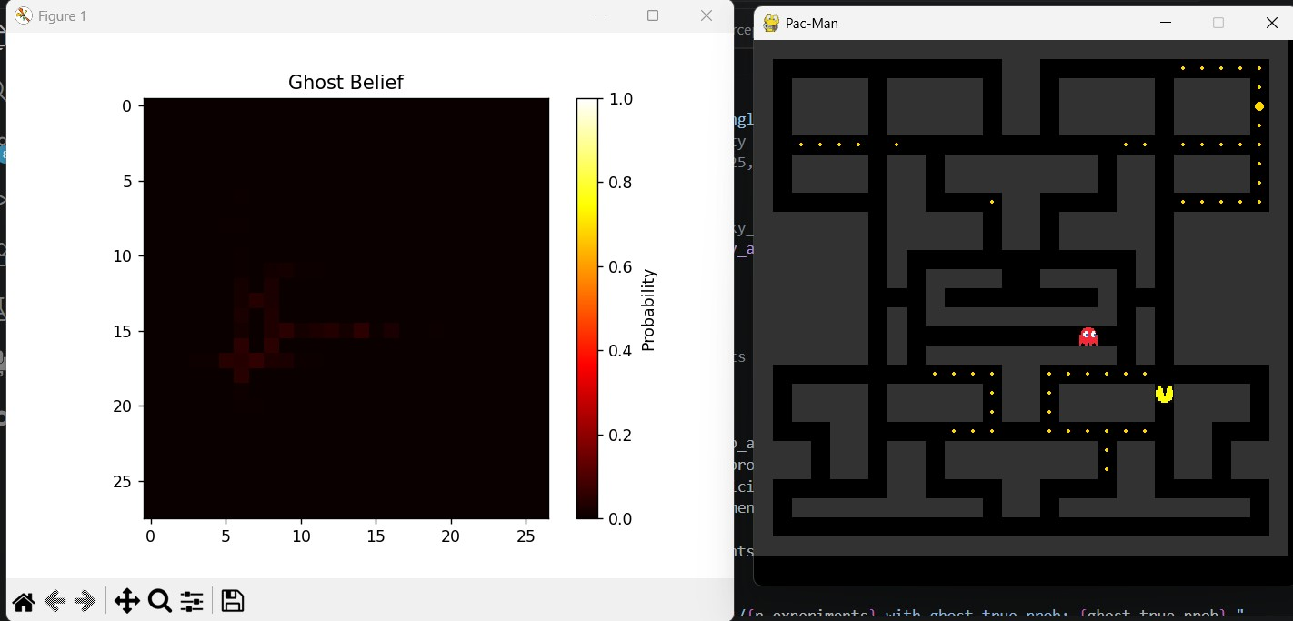
Sensor Probability=0.25
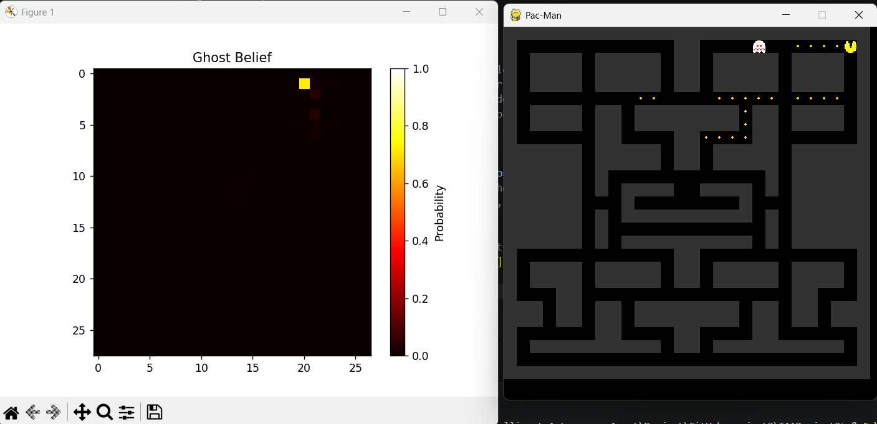
Sensor Probability=0.5
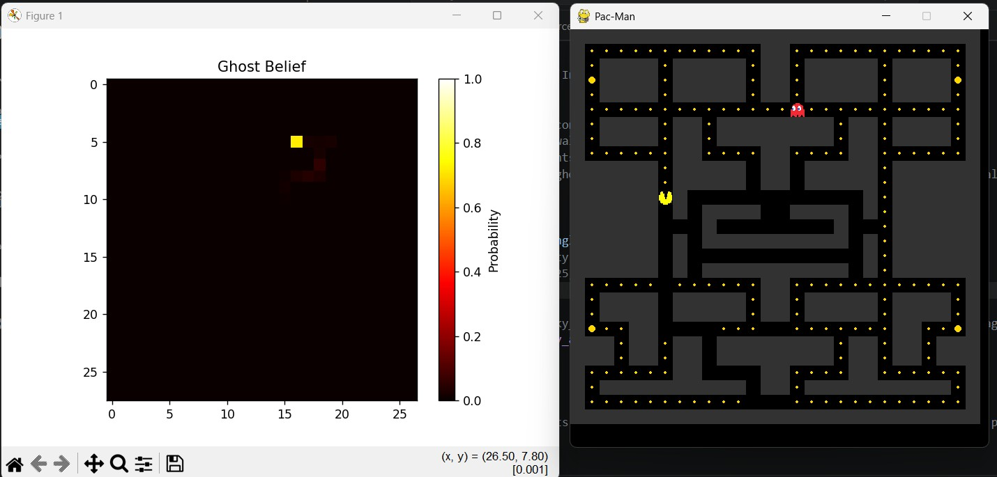
Sensor Probability=0.75
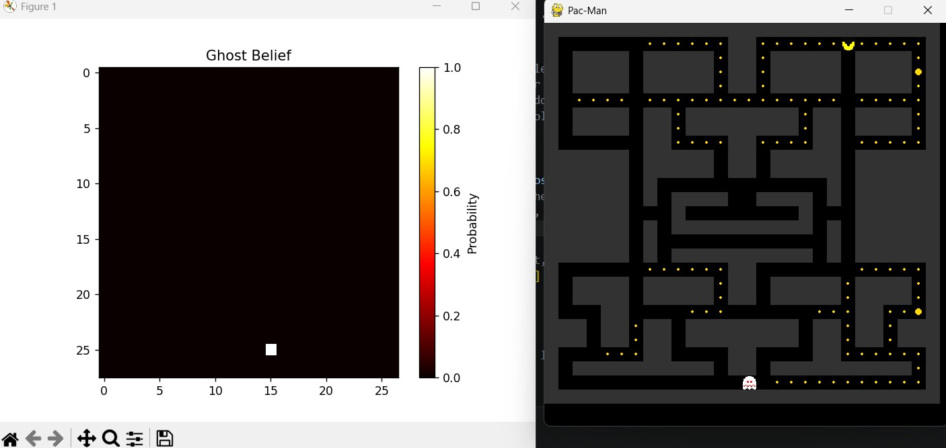
Sensor Probability=0.9
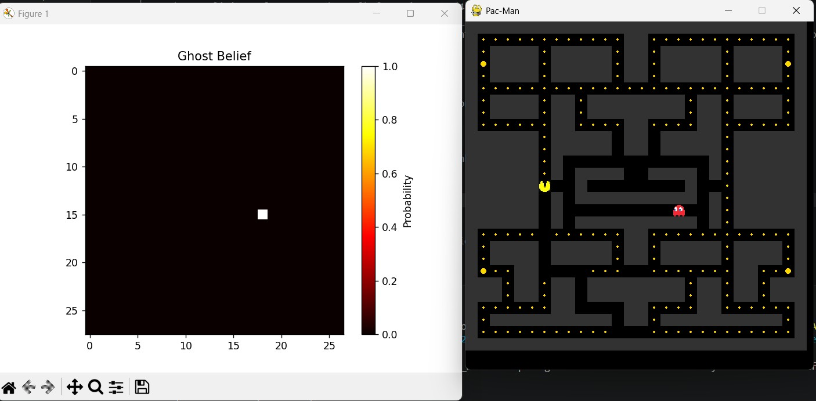
Figure 2

Sensor Probability=0.1
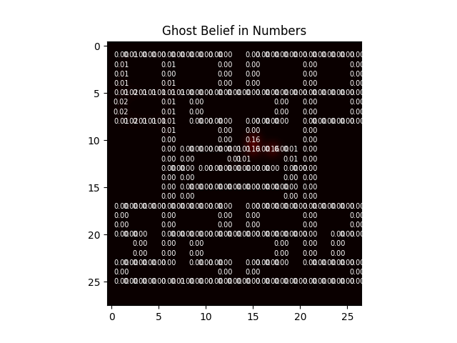
Sensor Probability=0.25
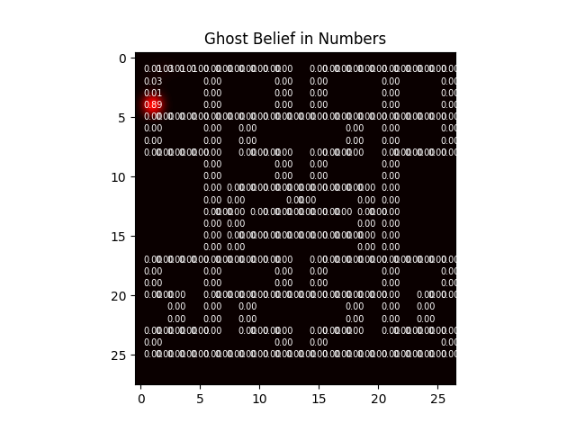
Sensor Probability=0.5
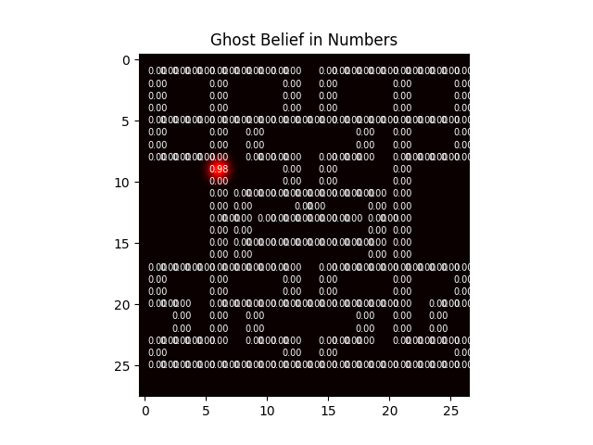
Sensor Probability=0.75
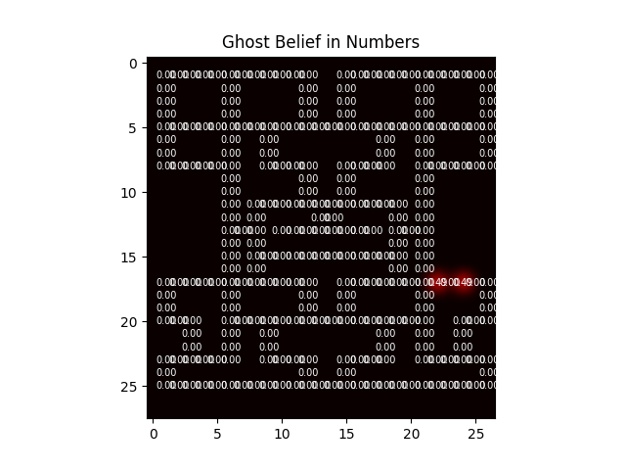
Sensor Probability=0.9
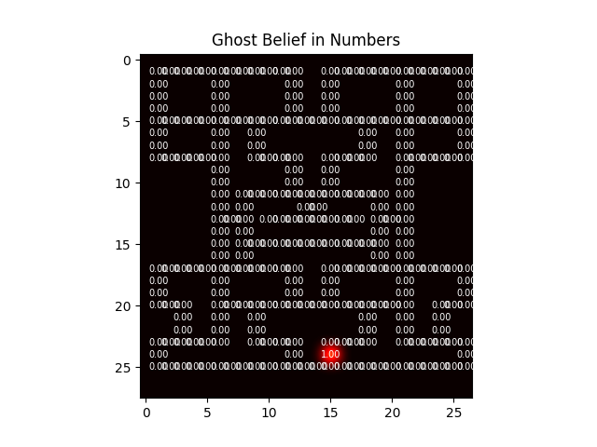
Figure 3

4. Changes required to our agent
We initially reused our agent from project 1 but very quickly discovered that we need to make significant changes.
4.1 New perception and direction logic
As required by the project, direct directional perceptions of the ghost (e.g., up, down) were no longer available. Instead, the agent relies on the HMM-based belief to estimate the ghost’s most likely position. To exploit this information, a distance-based perception was introduced, computing the distance between Pac-Man and the estimated ghost location. This metric is used to guide decision-making, allowing the agent to dynamically choose between chasing, evading, or collecting food depending on the inferred ghost state. Additionally, access to both positions enables more informed movement selection, improving efficiency in both pursuit and avoidance behaviors.

4.2 Local loops and the single ghost problem
An issue that quickly emerged when using a single ghost, particularly Blinky (which consistently moves toward Pac-Man), was the occurrence of local loops. This behavior resulted from the deterministic nature of the movement strategy, causing the agent to become trapped in repeating cycles. Several memory-based approaches were explored to detect and break these loops, including more complex solutions. However, a simpler strategy was ultimately adopted based on tracking the number of turns since Pac-Man last consumed food. Specifically, if no food is eaten within a fixed number of steps (50), the agent temporarily abandons ghost-avoidance behavior and prioritizes food search. Although this approach may occasionally result in Pac-Man’s immediate capture, it effectively breaks local loops while requiring significantly less memory and implementation complexity.
4.3 Another local loop
However, this approach did not completely eliminate all local loops. It was observed that when Pac-Man was solely searching for food and no food was detected within the perception range, the agent could still enter a cyclic behavior. In this case, a simple modification was applied by reversing the order in which valid directions were evaluated, which proved sufficient to break the loop.

5. Extra challenge
An additional HMM was implemented to estimate whether the ghost is in a frightened state. This replaced the direct ghost-frightened perception and was integrated into the agent’s decision-making process to determine whether to chase or evade the ghost. The default noisy sensor probabilities (0.9, 0.1) were maintained. As shown in Figure 4, the overall scores decreased across all sensor probability settings, which was expected due to the reduction in sensor accuracy from a perfect (100%) perception to a probabilistic one.

Sensor Probability=0.1
Ghost Name | Average Score | Max Score | Min Score | # of Wins
Inky  | 223.18 | 279.0 | 68.0 | 14
Blinky  | 179.02 | 275.0 | 37.0 | 2
Pinky  | 196.76 | 287.0 | 37.0 | 6
Clyde  | 200.37 | 289.0 | 59.0 | 1
Sensor Probability=0.25
Ghost Name | Average Score | Max Score | Min Score | # of Wins
Inky  | 236.11 | 289.0 | 85.0 | 30
Blinky  | 156.88 | 285.0 | 62.0 | 0
Pinky  | 180.35 | 281.0 | 64.0 | 5
Clyde  | 191.08 | 289.0 | 52.0 | 4
Sensor Probability=0.50
Ghost Name | Average Score | Max Score | Min Score | # of Wins
Inky  | 251.12 | 288.0 | 87.0 | 49
Blinky  | 179.28 | 289.0 | 64.0 | 1
Pinky  | 196.81 | 284.0 | 64.0 | 2
Clyde  | 229.50 | 289.0 | 68.0 | 7
Sensor Probability=0.75
Ghost Name | Average Score | Max Score | Min Score | # of Wins
Inky  | 259.98 | 289.0 | 128.0 | 54
Blinky  | 189.79 | 284.0 | 66.0 | 1
Pinky  | 201.89 | 287.0 | 66.0 | 0
Clyde  | 229.63 | 289.0 | 72.0 | 6
Sensor Probability=0.90
Ghost Name | Average Score | Max Score | Min Score | # of Wins
Inky  | 250.23 | 289.0 | 22.0 | 60
Blinky  | 200.69 | 289.0 | 66.0 | 1
Pinky  | 208.32 | 287.0 | 66.0 | 1
Clyde  | 238.73 | 289.0 | 66.0 | 13
Figure 4

6. Conclusions
This project demonstrated the effectiveness of probabilistic reasoning in addressing decision-making under uncertainty. By replacing direct ghost perception with a Hidden Markov Model, the agent was able to estimate the ghost’s position using a belief distribution that was continuously updated through Bayesian filtering. The results clearly showed that increasing sensor accuracy leads to more reliable belief states, which in turn improves overall agent performance.
The integration of the belief state into the agent’s decision-making significantly enhanced its behavior compared to the original reactive approach. By using distance-based reasoning derived from the estimated ghost position, the agent was able to dynamically switch between avoidance, pursuit, and food collection strategies. This demonstrates the practical value of combining probabilistic inference with reactive control in autonomous agents.
Several challenges were encountered during development, particularly the issue of local loops caused by deterministic movement strategies. While more complex memory-based solutions were explored, simpler approaches—such as food-based escape conditions and directional adjustments—proved effective and computationally efficient. These solutions highlight the importance of balancing performance with implementation complexity.
Remark: ChatGPT assisted only with report wording and played no role in the core analysis or results.

